RestAssured API Testing:

Layers in an application:  
a) Front End Layer (Presentation Layer)  
b) API Layer (Business Logic Layer) (Application Layer)  
c) Database layer (Data Layer)

1. Client Server architecture:  
   a) 1 tier architecture: presentation layer and database layer are residing in one system

b) 2 tier architecture: Presentation layer and database layer are residing in different systems  
c) 3 tier architecture: presentation , database and business logic layer are present in different layers

1. API -> No need of URL or browser, we can directly access jar files, APIs are not a webservices  
   Webservices -> these are available in webservers, so we need URL,   
   Webservices are a kind of APIs
2. WebServices:  
   SOAP-> supports XML  
   REST -> supports XML and JSON
3. Components of Webservices:  
   WSDL -> Webservices Description Language  
   UDDI -> Universal Description Discovery and Integration
4. CRUD operations  
   C -> POST  
   R -> GET  
   U-> PUT  
   D-> Delete  
     
   All   
   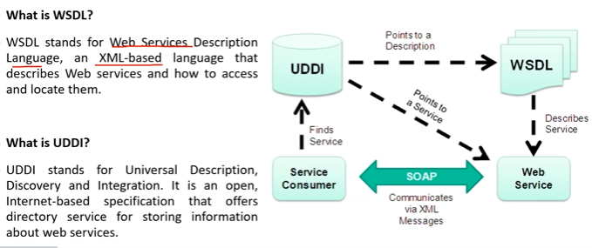
5. 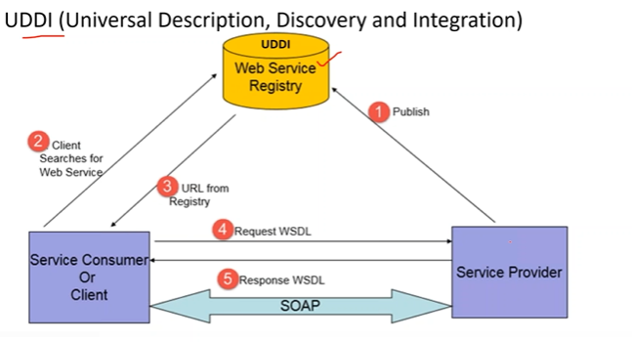
6. 
7. URL = Domain+URI+QueryString  
   URL -> Uniform Resource Locator  
   URI -> Uniform resource Identifier  
   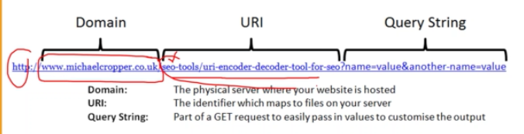
8. HTTP Requests must contain URL , Headers and payload
9. Rest Assured supports Rest Services only
10. Path Parameters
11. Query Parameters
12. 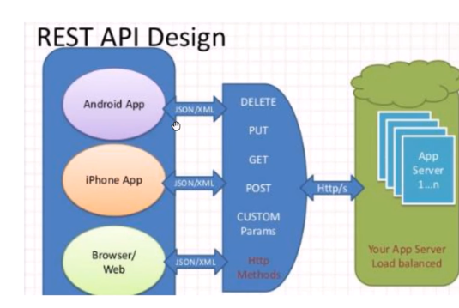
13. 
14. REST Services requests: GET,POST,PUT,PATCH,OPTIONS,HEAD,DELETE
15. Given().  
    when().  
    then().  
    extract();
16. 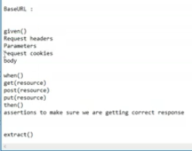
17. REST response will be in raw format, which inturn has to be converted to String format, which inturn can be converted to json using JSONPath
18. Log requests using  
    given().log().all()  
    given().log().header()  
    given().log().params()  
    given().log().body()  
    given().log().cookie()  
    given().log().method()  
    given().log().path()
19. Log response using  
    then().log().body()